Customer Churn Prediction
Week 4 Report: Model Optimization, Cross-Validation and Hyperparameter Tuning
NexAfrica Machine Learning Internship
Prepared by: GLORIA BOATENG

1. Overview
This report covers Week 4 of the Customer Churn Prediction project: analyzing class imbalance, experimenting with imbalance-handling techniques, applying cross-validation, and tuning hyperparameters to arrive at a final optimized model.

2. Class Imbalance Analysis
The target variable is imbalanced, as established in Week 1: 73.46% of customers did not churn versus 26.54% who did. In Week 3, this imbalance manifested as weak recall (49-52%) across all three baseline models, meaning roughly half of actual churners went undetected regardless of model choice. Week 4 directly addresses this weakness.

3. Imbalance Handling Techniques
Two techniques were tested on Logistic Regression: class weighting (class_weight='balanced') and SMOTE oversampling (synthetic minority over-sampling, applied only to the training set).
Approach | Precision | Recall | F1-Score | ROC-AUC
Baseline | 0.6554 | 0.5187 | 0.5791 | 0.8425
Class-Weighted | 0.5008 | 0.7914 | 0.6135 | 0.8421
SMOTE | 0.5377 | 0.6872 | 0.6033 | 0.8283
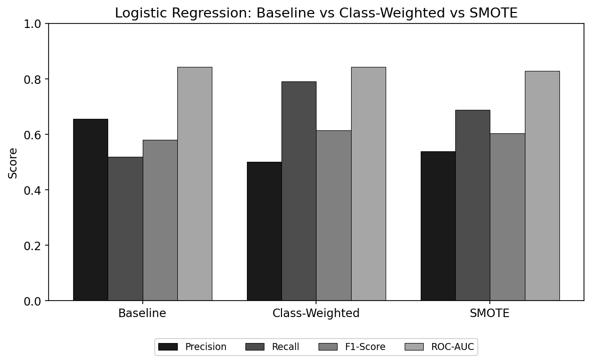
Figure 1: Logistic Regression, baseline vs class-weighted vs SMOTE
Both techniques substantially improved recall over the baseline. Class weighting achieved the strongest result (79.1% recall, F1 of 0.614) while preserving the baseline's ROC-AUC (0.842), whereas SMOTE's ROC-AUC dropped slightly (0.828), suggesting synthetic minority samples introduced marginally more noise than reweighting the real data directly. Class weighting was selected as the preferred imbalance-handling technique going forward.

4. Cross-Validation
5-fold stratified cross-validation was applied to the class-weighted Logistic Regression model to verify the stability of its performance across different data splits.
Metric | Mean | Std. Dev.
Accuracy | 0.7474 | 0.0124
Precision | 0.5156 | 0.0152
Recall | 0.7940 | 0.0357
F1-Score | 0.6251 | 0.0204
ROC-AUC | 0.8460 | 0.0114
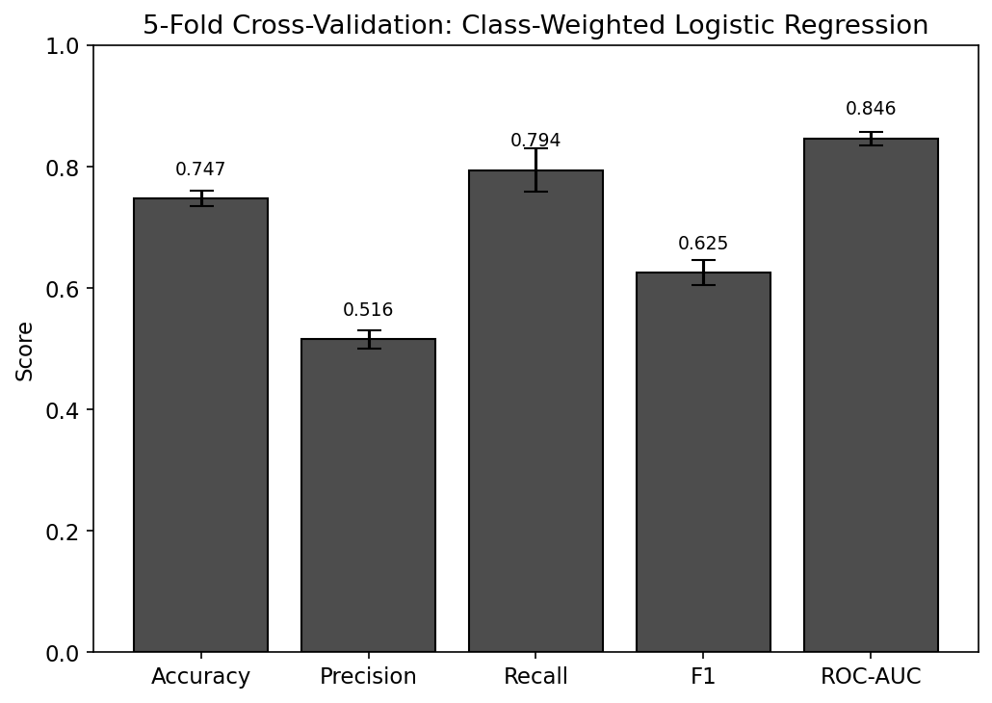
Figure 2: 5-fold cross-validation results (mean, error bars = standard deviation)
Results closely matched the single train/test split across all metrics, with low variance across folds, confirming the model's strong recall is a consistent, reliable property rather than a result of a favorable data split.

5. Hyperparameter Tuning
GridSearchCV was used to tune Random Forest, optimizing directly for recall given the business priority of catching at-risk customers. The search covered n_estimators, max_depth, min_samples_split, and class_weight.
Parameter | Best Value
n_estimators | 200
max_depth | 10
min_samples_split | 5
class_weight | balanced

Evaluated on the held-out test set, the tuned Random Forest achieved:
Metric | Score
Accuracy | 0.7580
Precision | 0.5303
Recall | 0.7727
F1-Score | 0.6289
ROC-AUC | 0.8423
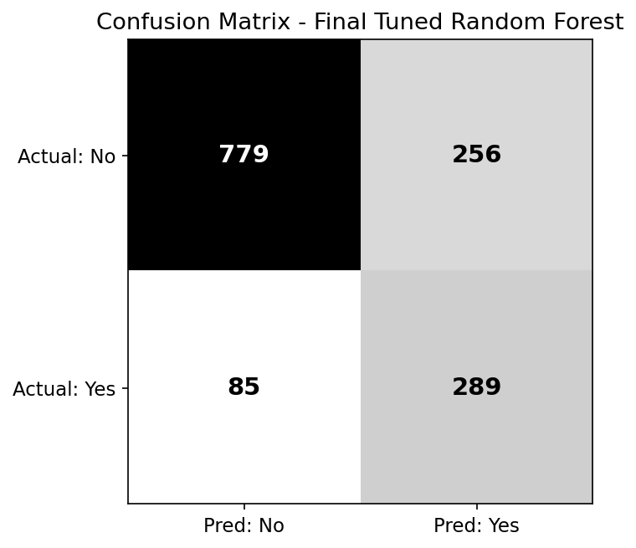
Figure 3: Confusion matrix, final tuned Random Forest

6. Final Model Comparison and Selection
The table below summarizes every configuration tested across Weeks 3 and 4.
Model | Precision | Recall | F1-Score | ROC-AUC
LR Baseline | 0.6554 | 0.5187 | 0.5791 | 0.8425
LR Class-Weighted | 0.5008 | 0.7914 | 0.6135 | 0.8421
LR SMOTE | 0.5377 | 0.6872 | 0.6033 | 0.8283
RF Baseline | 0.6216 | 0.4920 | 0.5493 | 0.8219
RF Class-Weighted | 0.5381 | 0.6417 | 0.5854 | 0.8196
RF Tuned (Final) | 0.5303 | 0.7727 | 0.6289 | 0.8423
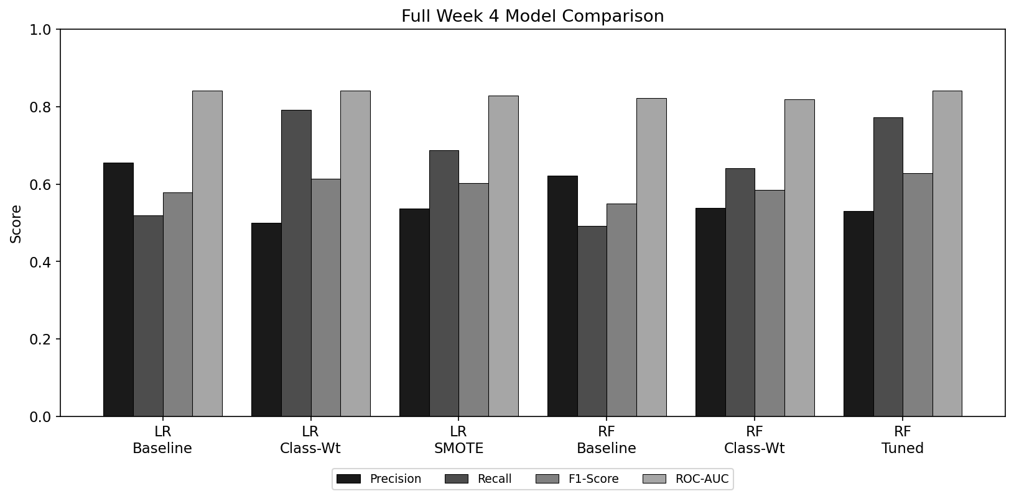
Figure 4: Full comparison across all models and configurations tested
The tuned Random Forest (n_estimators=200, max_depth=10, min_samples_split=5, class_weight='balanced') is selected as the final model. It achieves the highest F1-score of any configuration tested (0.629), recall of 77.3% (catching roughly 3 in 4 actual churners, versus roughly 1 in 2 for the Week 3 baseline models), and ROC-AUC of 0.842, matching the best untuned model's discriminative ability. While Logistic Regression with class weighting achieved marginally higher recall (79.1%), the tuned Random Forest offers a better overall balance between catching at-risk customers and minimizing false alarms, reflected in its superior F1-score, making it the preferred choice for deployment.
Final model selected: Tuned Random Forest Classifier.

